Linear Algebra
Magnitude/Len/L2 Norm:$\left|\left|x\right|\right|={\left|\left|x\right|\right|}_{2}={\left(\sum_{i}^{n}{x_{i}^{2}}\right)}^{1/2}$
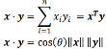
Normalizing: $x^{'}=\frac{x}{{\left|\left|x\right|\right|}_{2}}$
Dot Product:
Light and Color
Additive Color Mixing: spectral power distribution of mixture is sum of power distributions of components
Metamer: pairs of light that match perceptually but not physically
Linear Color Space: RGB (single wavelength primaries), CIE XYZ (y approximates brightness) ((x,y) = (X/(X+Y+Z), Y/(X+Y+Z)))
HSV: non-linear (hue is angle)
LAB: Magnitude is poor indicator of color distance; LAB fixes
Image Formation
Photometric: type, direction, intensity of light reaching sensor
Geometric: type of projection; camera pose
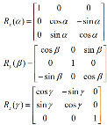
Optical: Sensor lens type; focal length, shutter speed, FOV
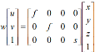
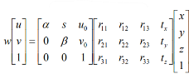
Projection Matrix: $x=K\left[R t\right]X$ $u=f\frac{X}{Z}+u_{0} v=f\frac{Y}{Z}+v_{0}$
$$R=R_{x}\left(α\right)R_{y}\left(β\right)R_{z}\left(γ\right)$$
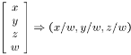
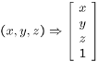
Scaled Orthographic Projection:
Homogeneous Coordinates:
Linear Filtering
S&P Noise: Random B/W pixels
Impulse Noise: Random W pixels
Gaussian Noise: variations in intensity from Gaussian Norm Dist.
Linear Filter: $\left[\begin{matrix}0 & 0 & 0 \\ 0 & 0 & 0 \\ 0 & 0 & 1\end{matrix}\right] Left/Up Shift \frac{1}{9}\left[\begin{matrix}1 & 1 & 1 \\ 1 & 1 & 1 \\ 1 & 1 & 1\end{matrix}\right] Blur Box$
$$\left[\begin{matrix}0 & 0 & 0 \\ 0 & 2 & 0 \\ 0 & 0 & 0\end{matrix}\right]-\frac{1}{9}\left[\begin{matrix}1 & 1 & 1 \\ 1 & 1 & 1 \\ 1 & 1 & 1\end{matrix}\right] Sharpening \left[\begin{matrix}1 & 2 & 1 \\ 2 & 4 & 2 \\ 1 & 2 & 1\end{matrix}\right] Gaus$$
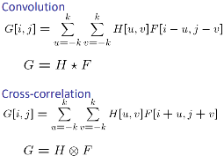
Gaussian Filter: removes high-frequency components from image (low pass filter). O(N^2 M^2)
Image Gradients and Edge Detection
Edge: rapid change in image intensity function
Directional Filter: $f=\frac{1}{9}\left[1,1,1,1,1\right] \left(row\right)$
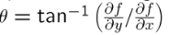
Finite Difference Filter: $M_{x}=\left[\begin{matrix}1 & 0 & -1 \\ 1 & 0 & -1 \\ 1 & 0 & -1\end{matrix}\right] \left(Prewitt\right) M_{x}=\left[\begin{matrix}-1 & 0 & 1 \\ -2 & 0 & 2 \\ -1 & 0 & 1\end{matrix}\right] \left(Sobel\right) M_{x}=\left[\begin{matrix}1 & 0 \\ 0 & -1\end{matrix}\right] and M_{y}=\left[\begin{matrix}0 & 1 \\ -1 & 0\end{matrix}\right] (Roberts)$
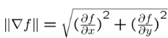
Image Gradient: (gradient direction)
(edge strength)
Noise: smooth before taking derivative to find edge
σ = Gaus smooth param (low = finer features, high = larger edges)
Edge Detection: 1) smooth (suppress noise) 2) contrast 3) edge locals
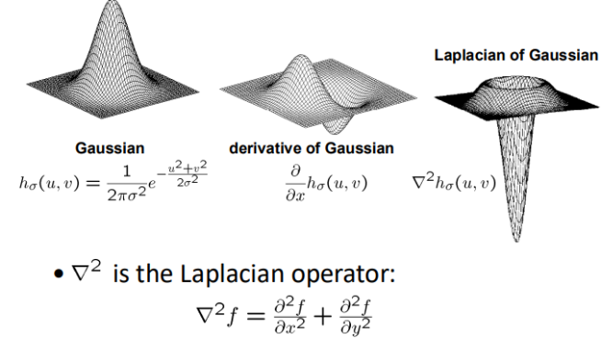
2D Edge Detection Filters:
Canny Edge Detector: filter img w/ deriv of Gaus, find mag and orient of gradient, thin ridges, threshold (h/l) to start curves (h) and continue them (l) via hysteresis
Local Feat I: Image Matching and Corners
Smoothing: pos vals, sum to 1 const regions same as input, smoothing amt proport to mask size, remove high-freq; low pass filter
Derivatives: neg sign to get high response from high contrast, sum to 0 no response in const regions, high abs val at points of high contrast
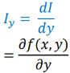
Local Features: Detection (identify pts), Description (extract vector feat descriptor), Matching (compute correspondence)
Corners: significant change in all directions
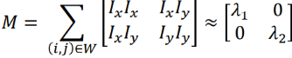
Axis corner. Look for places where both Lambda (eigen) are large.
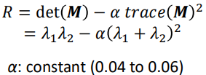
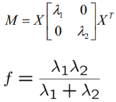
Harris Corner Detector: Cornerness score (compute M for each window), Threshold scores, local filter for corner regions (non max suppression). Rotation invariant but not scale invariant. Elementwise matrix mult.
Automatic Scale Selection: scale that gives local max in pos and scale. Corner = R > 0. Edge = R < 0
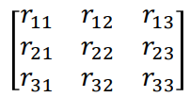
Local Feat II: Detection and Description
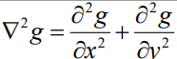
Rotation: Does NOT change L2 norm. Every r/c is unit norm. r’s are lin ind (full rank). Transpose is inv ($RR^{T}=R^{=T}R=I$). Det = 1 and eigenvalues are 1
Blob Detection: Laplacian of gaus. Characteristic scale produces peak of Laplacian response Edge=rippe; blob=superposition of two ripples. Spatial Selection: mag of Laplacian is max at center
Geometric Trans: scale, rotation, or translation
Photometric Transformations: color filter
Raw Patches: turn cluster of pixel intensities into feat vector (sensitive)
SIFT Descriptor: histogram to bin pixels within subpatches according to gradient orientation. 1) compute gradient 2) build histogram. Rotate patch according to dom gradient orient (rotation invariant) (canonical order). Scale invariant.
Matching: similar appearance (low SSD). Nearest neighbor (Euclidian dist) and threshold ratio of nearest to 2nd nearest descriptor for SIFT
Robust Feat-Based Alignment: 1) extract feats 2) compute potential matches 3) LOOP: 1) hypothesize transformation (small group of potential matches related by T) and (2) verify transformation (search for other matches consistent with T)
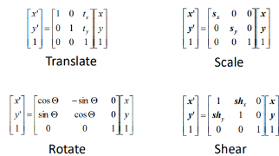
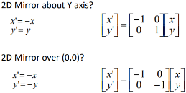
Fitting a Transformation: Feature-based Alignment
Transformations: Translation cannot be represented with 2D matrix
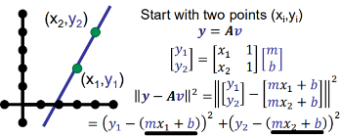
Affine transformation are combos of linear transformations and translations. Parallel lines remain parallel.
Least Squares:
r > c (over constrained) and c > r (under constrained)
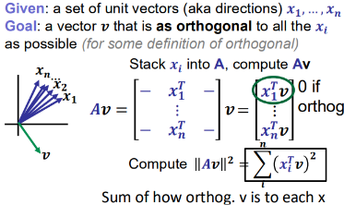
Homogeneous Least Squares:
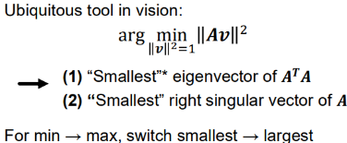
RANdom Sample Consensus (RANSAC): outliers ruin least squares. 1) randomly select seed group 2) compute transformation 3) find inliers to transformation 4) if inliers is large, compute estimate of all inliers 5) keep transformation with largest num of inliers. Many hyperparameters. Does not work well with low inlier ratios.
Image Warping and Stitching
Alignment: given two images, learn transformation
Warping: given source image and transformation, predict transformed output image
Mosaic: obtain wider angle view by combining multiple images. 1) Take a sequence of images from same pos 2) compute transformation 3) transform second img to overlap first image 4) blend together 5) repeat
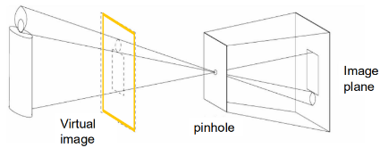
Pinhole Camera: model to approx. imaging process
Mosaic: reproject images onto common plane. Synth wide-angle camera
Image reprojection: cast ray from center of projection (COP) through each pixel in PP1 and draw the pixel where intersection in PP2
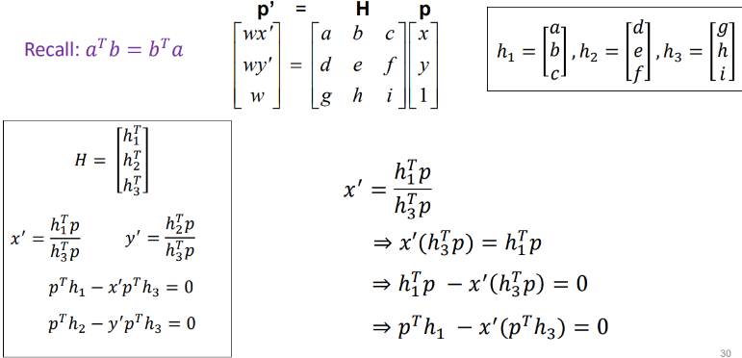
Homography: mapping btwn two project planes (PP) with same COP. Parallels not preserved. Preserve straights. Frobenius norm of H = 1.
Forward Warping: send pixel to location in f’. If pixel between two pixels, distribute color (splatting).
Inverse Warping: get each pixel from location in f’. If pixel between two pixels, interpolate color from neighbors (bilinear)

